FICTION AND FILM: TECHNIQUES POSTER

- Choose a partner for this project.

- Using your glossary and the materials provided, create a poster illustrating your understanding of the film terminology and your ability to identify examples of filmic style.

- Find an image (one image may contain multiple techniques) for each of the following:

- high angle
- long shot
- close shot
- high key lighting
- low key lighting
- low angle
- Dutch/canted angle
- sharp focus
- soft focus
- mise en scene—don’t forget to go back to this one later!

  - Glue each image on the poster and provide the following information for each image (see example below):
- Label the specific technique being used in the image (long shot, high angle, etc.)

- In sentence form analyze what the use of this technique contributes to the construction of visual meaning. In other words, explain what the use of the technique communicates/symbolizes in the specific image (ex-What is being represented/conveyed in the image? How does the typical “meaning” of a technique contribute to the particular image/representation?)

- Example:
LOW ANGLE: In the scene from The Shining, low angle is employed against its conventional method. Here, the character of Wendy is portrayed not as powerful but as fearful as she comes to realize just how insane her husband, Jack, really is. Low angle helps point the viewer to her terrified attention to the typewriter and manuscript in the foreground-what does she read? Additionally, tension mounts as the viewer is denied access to Wendy’s surroundings.
-adapted from Barsam video

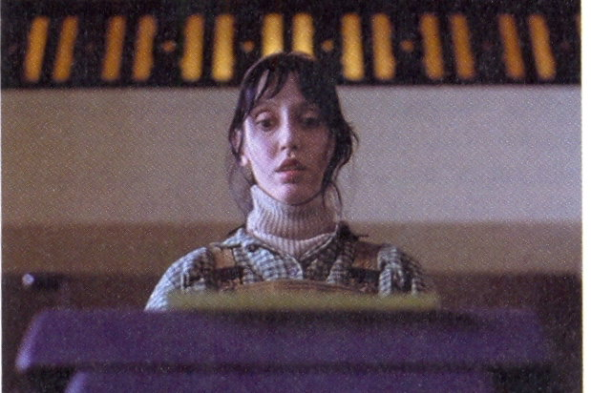

  - Find a series of images (at least three) that you will “edit” together in a meaningful sequence that visually communicates a narrative (story) through focalization AND one of these editing choices:
1) crosscutting 2) eyeline match 3) flashback/forward 4) shot/reverse shot.
You may find the images in the magazines provided or, for this portion, you may draw your own. Place your
sequence on the poster and complete the following information:
- Identify the editing method used.
- Identify what focalization (authorial, subjective, or neutral) is used in the sequence.
- Write a description of the narrative/story conveyed in the edited sequence.

  - Paper clip this assignment sheet/rubric to the front of your poster.

